# Exam Preparation

Tasks for exercise in class and for homework to the course ["Programming Fundamentals and Unit Testing" @ SoftUni](https://softuni.bg/trainings/4256/programming-fundamentals-and-unit-testing-september-2023)

Test your tasks in the Judge system: <https://judge.softuni.org/Contests/4454/Exam-Preparation-I>

# Sum Factorial Even Digits

Write a program that:

* Reads an integer number from the console
* Calculate sum of the factorials only on even digits of the given number
* Print the calculated sum

# Example Input / Output

|  |  |  |
| --- | --- | --- |
| **Input** | **Output** | **Comments** |
| 4532 | 26 | First digit is 4, it is even so we calculate factorial: 4! = 4 * 3 * 2 * 1 = 24  Second digit is 5, it is odd so we skip it.  Third digit is 3, it is odd so we skip it.  Forth digit is 2, it is even so we calculate factorial: 2! = 2 * 1 = 2  Sum of factorials: 24 + 2 = 26 |
| 468 | 41064 | First digit is 4, it is even so we calculate factorial: 4! = 4 * 3 * 2 * 1 = 24  Second digit is 6, it is even so we calculate factorial:  6! = 6 * 5 * 4* 3 * 2 * 1 = 720  Third digit is 8, it is even so we calculate factorial:  8! = 8 * 7 * 6 * 5 * 4* 3 * 2 * 1 = 40320  Sum of factorials: 24 + 720 + 40320 = 41064 |

# Middle Elements

Write a program that:

* Reads an array of integer numbers from the console, separated by single space
* Array length will always be even number.
* Calculate the average value of the elements in the middle of the array
* Print the result formatted to the second digit

# Example Input / Output

|  |  |  |
| --- | --- | --- |
| **Input** | **Output** | **Comments** |
| 3 4 6 7 8 9 | 6.50 | Middle elements are: 6 and 7  Average value: (6 + 7) / 2 = 13 / 2 = 6.50 |
| 12 34 98 42 65 12 | 70.00 | Middle elements are: 98 and 42  Average value: (98 + 42) / 2 = 140 / 2 = 70 |

# 3. Unit Test Method: Center Point

Test a given method which takes in **coordinates of 2 points** and determines which point is **closer to the center (0,0)**.

The method is found in the CenterPoint.cs file:

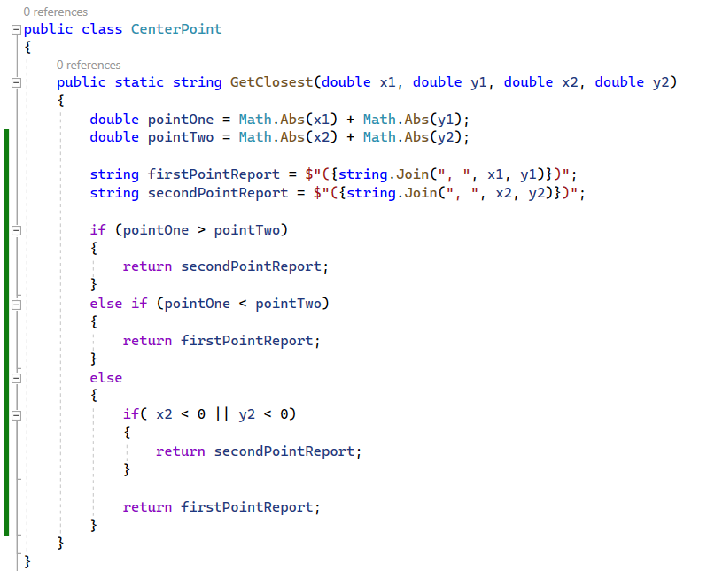

You are given a **test** **file** CenterPointTests.cs containing **5 empty tests**. Implement all the unit tests:

When you are ready make sure your **tests run:**

**IMPORTANT:** **DO NOT REMOVE OR CHANGE ANY NAMESPACES AND USINGS.**

# 4. Unit Test Array: Fold Array

Test a given method which takes in **an integer array** of 4*k integers, then folds it like shown below, and returns the sum of the **upper** and **lower** two rows (each holding 2*k integers):

The method is found in the FoldSum.cs file:

You are given a **test** **file** FoldSumTests.cs containing **5 empty test cases**. Implement all the cases:

When you are ready make sure your **tests run:**

**IMPORTANT:** **DO NOT REMOVE OR CHANGE ANY NAMESPACES AND USINGS.**